Initial Network Config

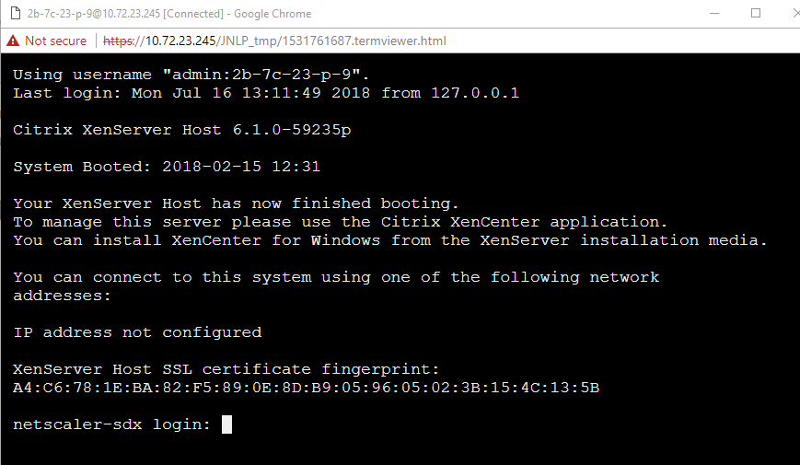

Default Password: root/nsroot

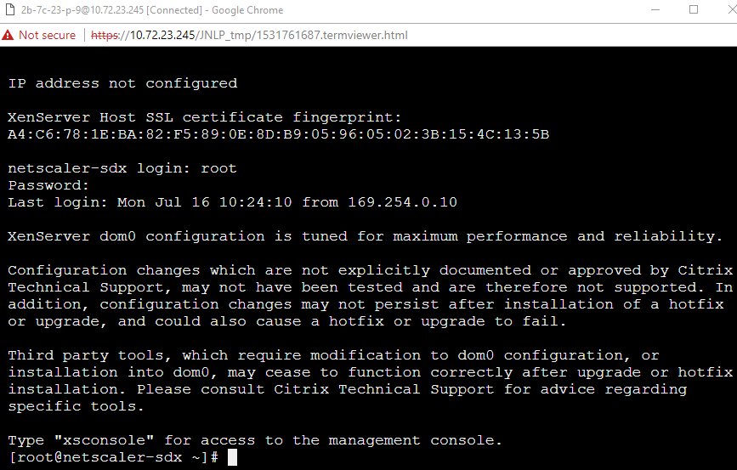

At the prompt, type: ssh nsroot@169.254.0.10 When prompted for the password, type nsroot

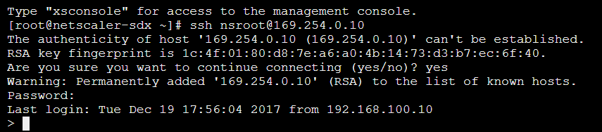

At the shell prompt, type:

set networkconfig gateway=<ipaddress> xen_ip_address=<ipaddress> network_interface=<string> svm_ip_address=<ipaddress> netmask=<ipaddress>



Firmware Upgrade

http://{svm_ip_address}

nsroot/nsroot

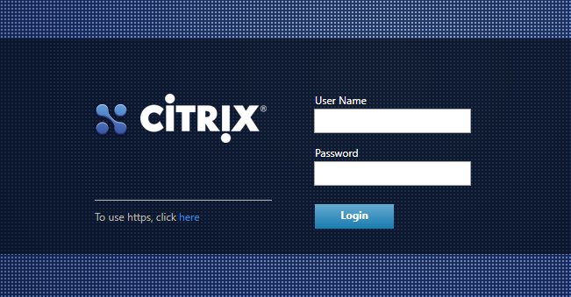

Configuration…Management Service…Software Images

Upload

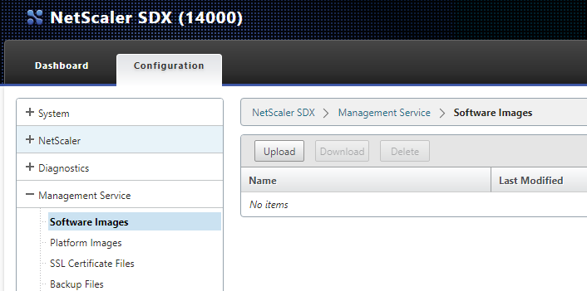

\\foo.bar\shares\FS001\Citrix\Citrix\SDX-12.0-53.6\build-sdx-12.0-53.6.tgz

Upgrade by clicking System…System Administration…Upgrade Management Service

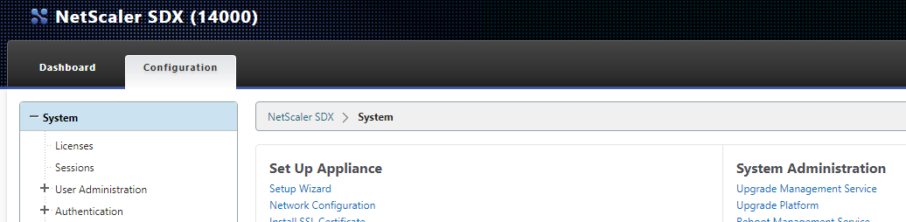

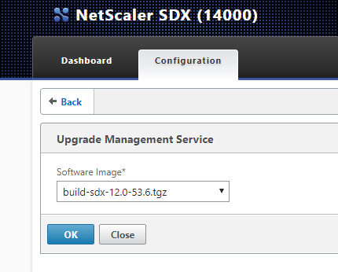

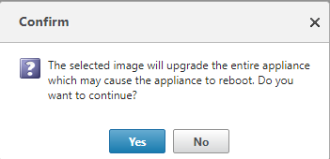

This will take a long time. Do not freak out. After a while, reloading the page will show a progress bar…

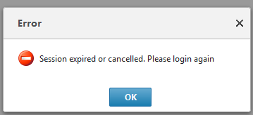

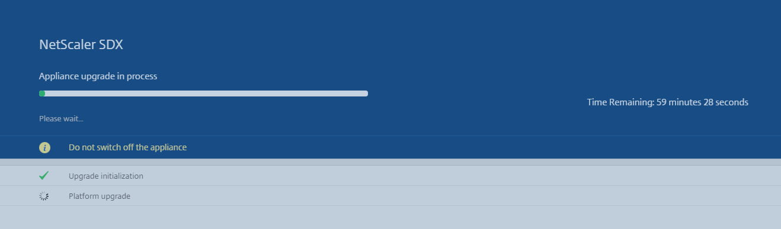

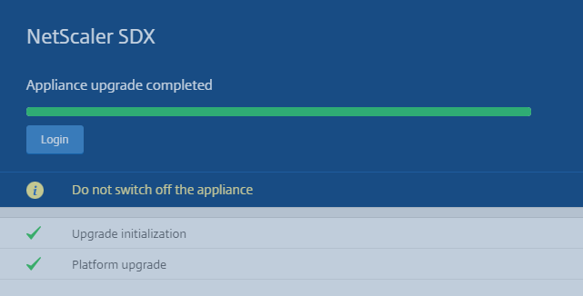

Change Default Password

Login

Skip the User Experience Setup

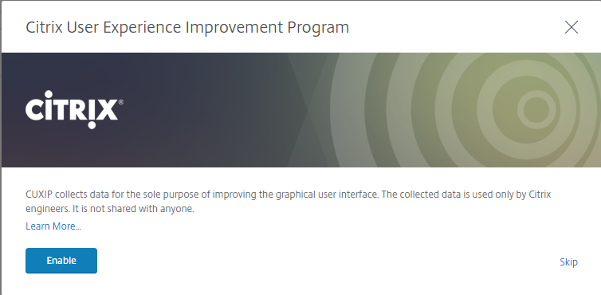

Reset nsroot password

Add PIM Entry

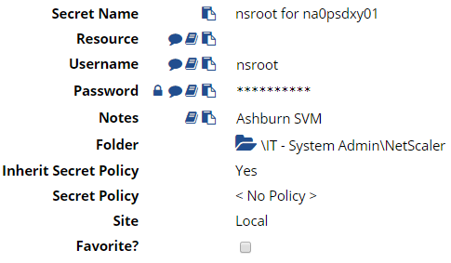

System…User Administration…Users

*** NOTE: This also changes the “root” password for XenServer ***

Edit nsroot, change password

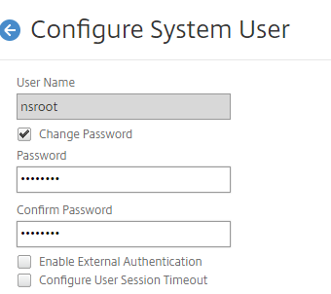

Configure LOM

System…Console…XenServer

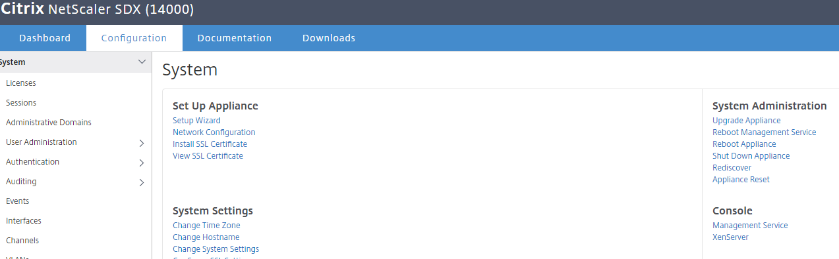

Ipmitool lan print 1 and get the MAC Address

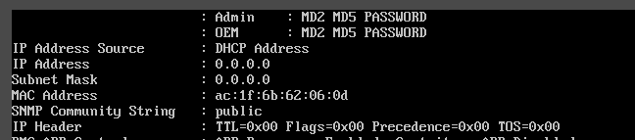

Add Fixed Address in InfoBlox for the MAC address.

Ipmitool lan set 1 ipsrc dhcp

Ipmitool mc reset warm

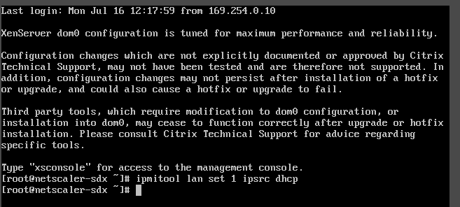

Ipmitool lan print 1

Verify DHCP address

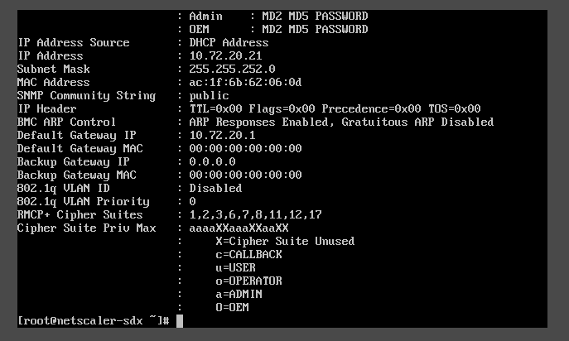

Connect to LOM via browser nsroot/nsroot

Add Entry in PIM

Configuration…Users…nsroot…Modify User

Change LOM password

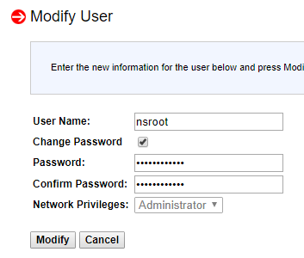

If setting a static IP address, use: ipmitool lan set 1 ipaddr IP_Address

Ipmitool lan set 1 netmask netmask_address

Ipmitool lan set 1 defgw ipaddr gateway_server

Licensing

Login to [www.citrix.com](http://www.citrix.com)

All Licensing Tools

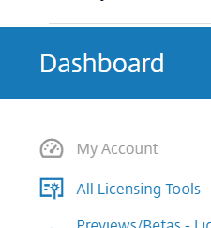

Activate and Allocate Licenses

Find Citrix NetScaler Zero Capacity SDX Z License and Select it

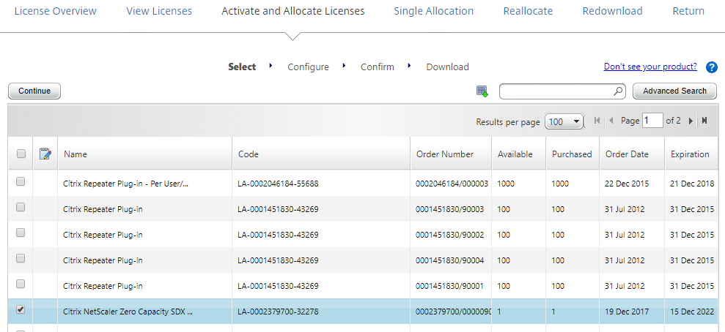

Click Continue

From the SDX System Information page, select and copy the Host ID

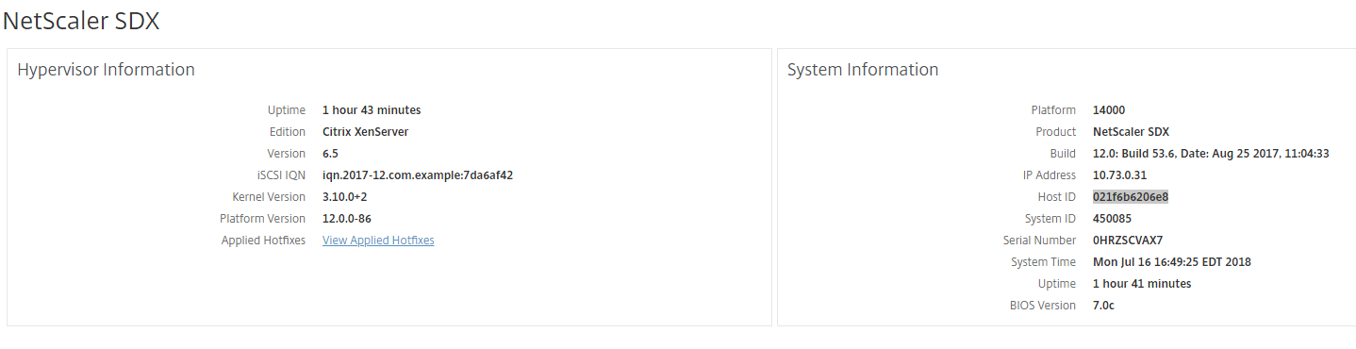

Paste it in the Host ID field on the Citrix License page

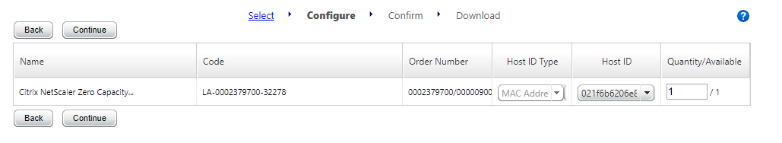

Confirm and Download the license file.

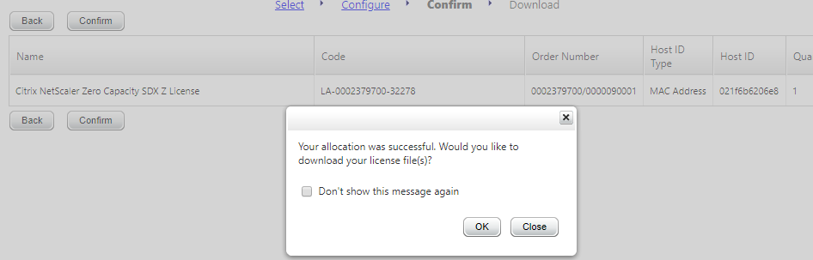

Save the file in:

\\foo.bar\shares\FS001\Citrix\Citrix\licenses\SDX-Zero

As the SDX hostname-mac address.lic (ie: na0psdxy01-021f6b6206e8.lic)

On the SDX, System…Licenses…Upload license files from a local computer

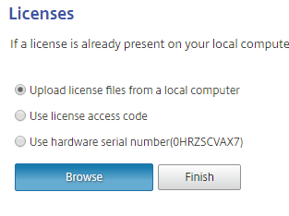

Click Finish.

Enter the NMAS information using the nsroot password in PIM for nt0pctxmas01\nsroot

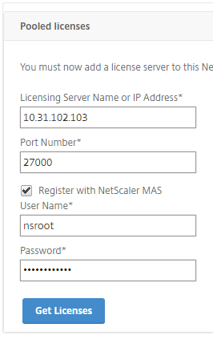

Allocate licenses as appropriate

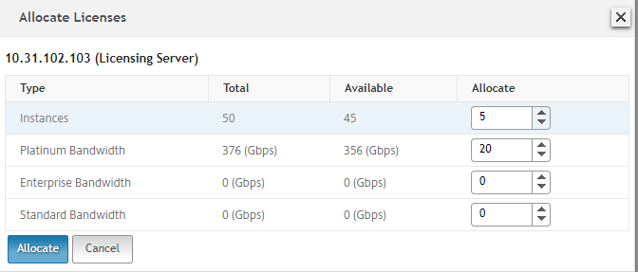

Apply Licenses. Verify Licenses Applied Successfully



SSL Certificate

System…Set Up Appliance…Install SSL Certificate

\\foo.bar\shares\FS001\Citrix\Citrix\SSL\Certificate_Wildcard\

Password: PIM secret: wildcard.foo.bar

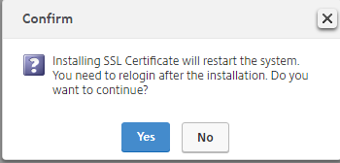

SSL Configuration

System…System Settings…Configure SSL Settings

Edit Settings… Protocol Settings

Enable TLSv1.2 ONLY

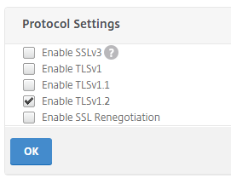

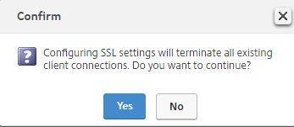

Edit Settings…Cipher Suites

Cipher Groups...HIGH

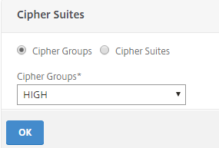

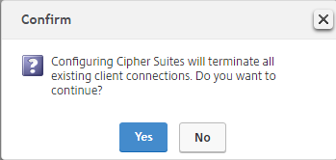

Enable LDAP Authentication

System…Authentication…LDAP…Add

Use Bind Password from PIM: Netscaler LDAP bind account

System…User Administration…Groups…Add

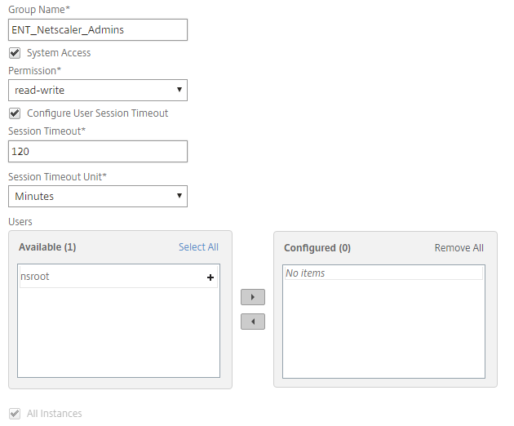

System…Authentication…Authentication Configuration

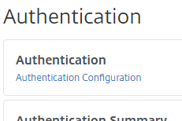

Change to EXTERNAL and Insert LDAP

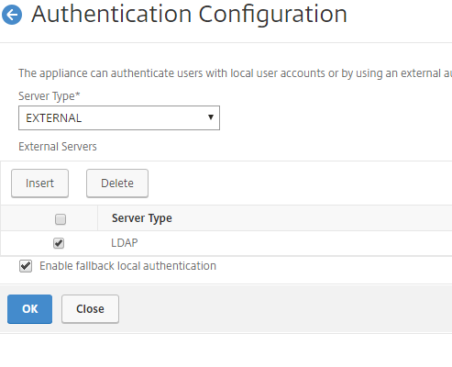

LACP Channels

System…Channels…Add

LA/1 – 10/1 and 10/9 – VLAN 245 (Southbound - DMZv2), VLAN 241 (Northbound - DMZv2) – PROD

VLAN 1502 (Southbound – DMZv3), VLAN 1550 (Northbound – DMZv3) – PROD

LA/2 – 10/2 and 10/10 – VLAN 1513 (Southbound), VLAN 1556 (Northbound) – STG

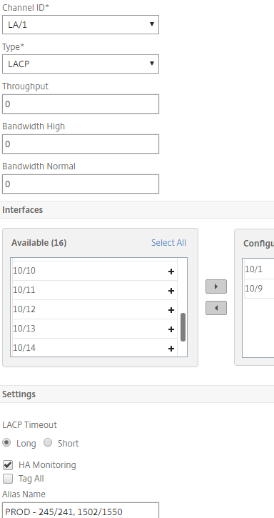

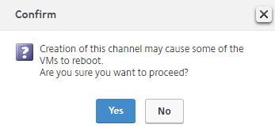

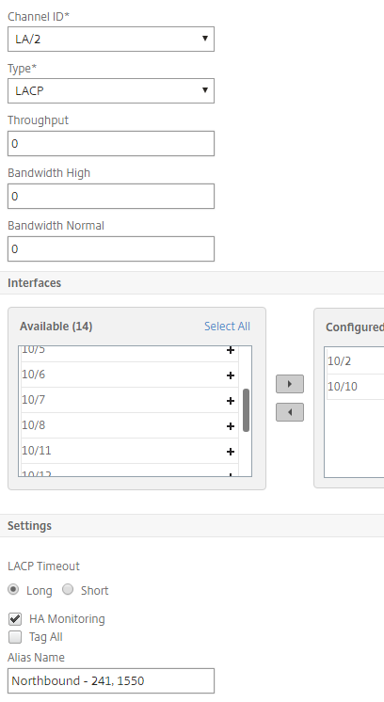

Disable Unused Interfaces

System…Interfaces

Disable each Down Interface

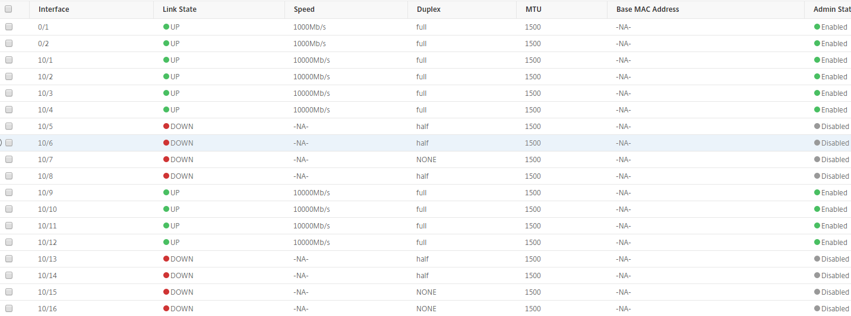

SYSLOG Configuration

System…Auditing…Syslog Servers…Add

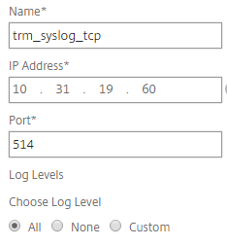

Syslog Parameters

Change Time Zone to Local

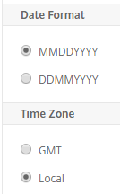

SNMP Configuration

System…SNMP…Settings…Configure SNMP MIB

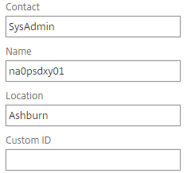

System…SNMP...Trap Destinations…Add

Zenoss:

NMAS:

System…SNMP...Managers…Add

Add st0pzenrn01.foo.bar through st0pzenrn04.foo.bar

System…SNMP...Users…Add

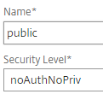

System...Alarms

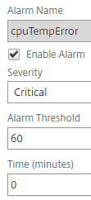

Set the following Alarms as Critical:

* cpuTempError
* cpuTempNormal
* cpuUsageHigh
* cpuUsageNormal
* diskUtilizationHigh
* diskUtilizationNormal
* fanSpeedError
* fanSpeedNormal
* interfaceDown
* interfaceUp
* ipmiStateError
* ipmiStateNormal
* logicalDriveFailed
* loginFailure
* memoryUsageHigh
* memoryUsageNormal
* networkConfigChanged
* physicalDriveFailed
* powerSupplyFailed
* powerSupplyNormal
* systemTempError
* systemTempNormal
* voltageError
* voltageNormal

Backup Configuration

Management Service…Backup Files

Delete default backups

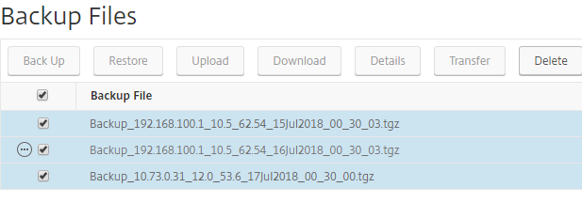

Make a New Backup File.

Upload NetScaler XVA Firmware

NetScaler…Software Images...XVA Files…Upload

Browse to the XVA file (downloaded from Citrix Site).

Note: This is downloaded as a .tgz file, extract the .xva file from the TAR file and use this for uploading to the SDX

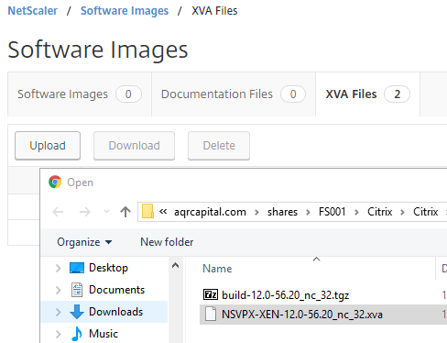

Create VPX Admin Profile

NetScaler…Admin Profiles…Add

Use the naming convention: site_nsroot_environment_int/ext

Record the password in PIM

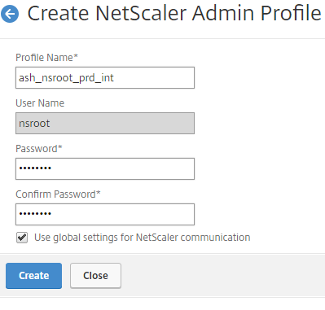

Create VPX Instance

NetScaler…Instances…Add

Name/IP Address/XVA Firmware/Profile:

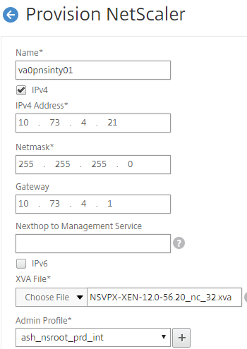

License:

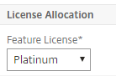

Bandwidth Throughput (Prod):

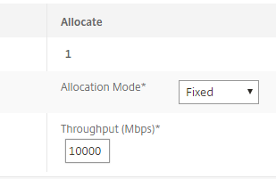

Resources (Prod):

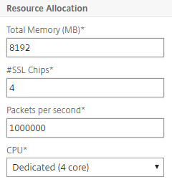

Network:

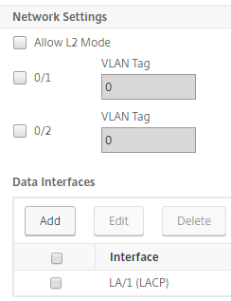

Click Done

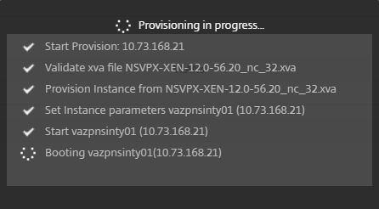

Note: This will take several minutes, and will ultimately time out – this is because the VPX Instance is not on the proper VLAN for administration. This will be adjusted in the next steps. Watch for the line stating “Booting…”. After 10 minutes, you may refresh the page and return to the Instances page.

Configure VPX VLAN

NetScaler…Instances…Console

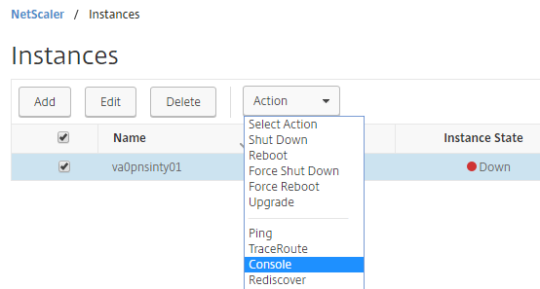

Note: If no response, reboot the instance once.  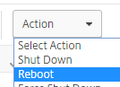

Login using the nsroot account set up in PIM

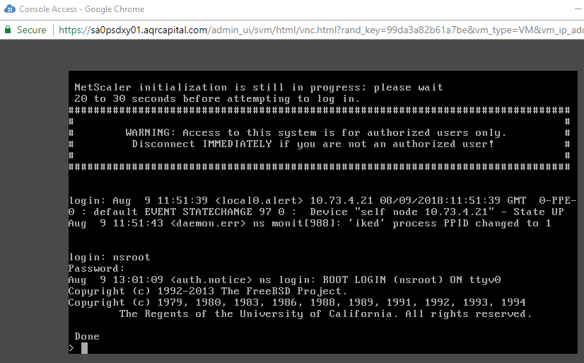

Enter the following commands:

add vlan xxx

Use the appropriate VLAN ID

bind vlan xxx -ifnum LA/y -tagged

Use the appropriate Link Aggregate Channel

save config

Use ping to check communication to the gateway.

Verify that the SDX shows the instance as Running/Up

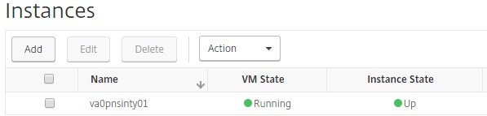

Basic VPX Configuration

As a pre-requisite, you need WinSCP and the WinSCP PowerShell Wrapper installed.

* Install WinSCP
* Open Admin PowerShell Command Line and run “Install-Module -Name WinSCP“

Go to GitHub to retrieve the NetScaler_basic_setup.ps1 script

Open a PowerShell Command Window

Execute the NetScaler_basic_setup.ps1 script

Provide the following information:

* NSIP
* SNIP
* NetMask
* Host Name
* Credentials (nsroot from PIM as defined above)

After the script completes, there will be a file called H:\{hostname}-initial.txt. Review the contents of this file for any errors.

Login to the GUI of the NetScaler using LDAP credentials to verify.